Demographics
What is your age?
What is your gender?
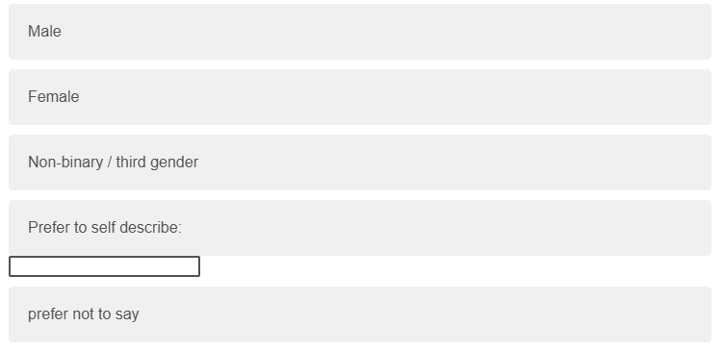
What degree program are you currently enrolled in?
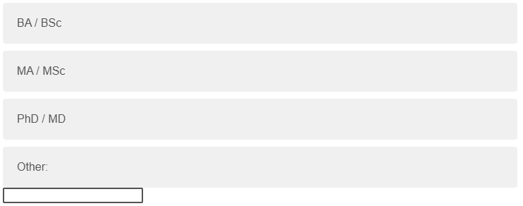
What is your main field of study?
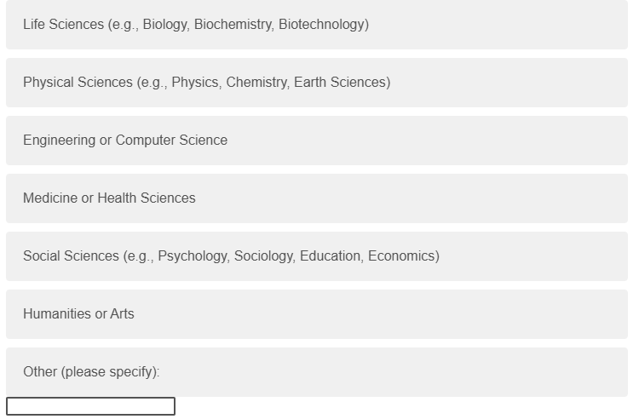
---------------------------------------------------------------------------------------
Explainability
Please indicate your level of agreement with the following statements:
Clarity: The feedback clearly explained my communication during the conversation.

Understandability: From the feedback, I understand how I communicated during the conversation.

Completeness: The feedback addressed all the important aspects of my communication. 
Satisfaction: The feedback was satisfying in capturing my communication during the conversation. 
Usefulness: The feedback was useful for improving my communication skills.

Accuracy: The feedback accurately reflected my communication during the conversation.

Insight: The feedback provided insights about my communication that I was not aware of during the conversation.

Explainability (Justification): The feedback helped me understand why the specific comments in the feedback were given to me.
Explainability (Depth): The feedback provided sufficient explanation for its evaluations.

Preference: I would prefer receiving feedback in this format compared to other forms of feedback (e.g., brief comments, grades only, or no feedback).


---------------------------------------------------------------------------------------
User Experience
To what extent did you find the practice helpful for improving your communication skills?

Please indicate your level of agreement with the following statement: “I would recommend this practice to other students who wish to improve their science communication skills”.

In the second conversation, did you change the way you communicated with the simulator? If yes, what did you change and why?

Did you learn something new during this practice? If so, what did you learn?

We would love to hear any comments or suggestions you have regarding this tool:

-----------------------------------------------------------------------------------------------


